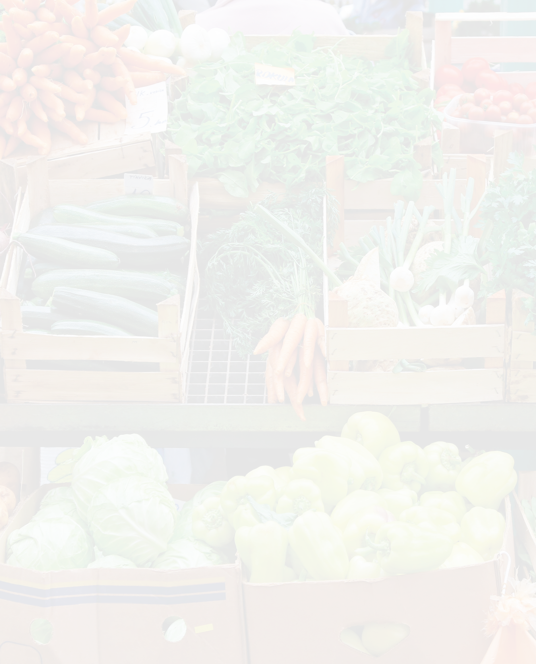

Cov Neeg Xauj* thiab cov tswv tsev

tau txais DAWB kev mus saib xyuas ntawm Pab Pawg Hluav Taws Xob Hauv Tsev uas lawv yuav nruab:

* Teeb LEDs • Qhov rooj kaw cua
* Cov cua sov uas siv pos kees (programmable)• Thiab lwm yam

THIAB

Tau txais daim ntawv khoom plig DAWB $20 Cov Nyiaj Kiab Khw txhawm siv rau ntawm kiab khw txhiam laj txhiam xwm hauv koj lub zej zog

Teem sij hawm mus saib xyaus dawb ntawm koj hnub no hu rau 651-328-6220

Txhuas tus yuav tsum muaj kev nkag tau rau cov zaub mov tshiab, noj qab nyob zoo, zaub mov hauv zej zog. Cov Nyiaj Kiab Khw pab cov neeg yuav khoom SNAP nthuav siv lawv cov nyiaj dos las ntawm lub kiab khw txhiam laj txhiam xwm los ntawm kev ua cov zaub mov muaj txiaj ntsig zoo rau lub cev uas tuaj yeem muaj nyuav tau ntau. Koj tuaj yeem yuav SNAP cov khoom noj uas tsim nyog tau muaj nyob ntawm lub khw txhiam laj txhiam xwm.

Zoo siab koom tes nog:

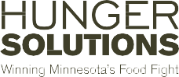

***“Kuv tau zoo siab heev uas tau txais cov teeb taws tshiab tag nrho lawm thiab tau nruab cov khoom kaw cua yam uas dawb.”***

**- Kathy, St. Paul tus tswv tsev**

Koj qhov kev mus saib xyuas ntawm Pab Pawg Hluav Taws Xob Hauv Tsevyam dawb yog suav nrog pab pawg kws pab tswv yim txog hluav taws xob uas yuav tuaj rau hauv koj lub tsev, txheeb xyuas koj cov tsam thawj txuag hluav taws xob, thiab muab cov kev pab cuam no (raws li koj lub tsev xav tau):

* Nruab cov khoom siv pub dawb xws li cov teeb LED, cua sov uas siv pos kees (programmable), lub qhov rooj thiab qhov rooj nthab tse uas kaw cua, lub tso dej da uas muaj txiaj ntsig zoo thiab cov tshuab cua rau kais dej
* Kev ntsuam xyuas koj lub nthab thiab phab ntsa cov rwb yas thaiv tsev
* Kev ntsuam xyuas kev kev nyab xeeb txog kev rauv taws thiab ntsua xyuas pa taws (carbon monoxide)
* Daim ntawv ceeb toom uas tau hloov pauv

Thaum koj ua tiav qhov kev tuaj saib xyuas koj yuav tau txais daim ntawv khoom plig $20 Cov Nyiaj Kiab Khw qhia tau tias tuaj yeem siv tau ntawm cov kiab khw txhiam laj txhiam xwm.

* Pab Pawg Hluav Taws Xob Hauv Tsev muaj rau cov tswv tsev thiab cov xauj tsev li ntawm 1-4 lub tsev siab.

